**BytePro Factual Data Process**

Factual Data by CBC is a credit vendor intended for use on loans with borrowers who have an ITIN rather than a SSN.

The process to pull credit using Factual Data by CBC is completed as shown in the steps below.

Note: The borrower’s actual ITIN number is to be displayed in Byte Pro rather than 111-11-1111

1. From your loan file, select Interface -> Credit

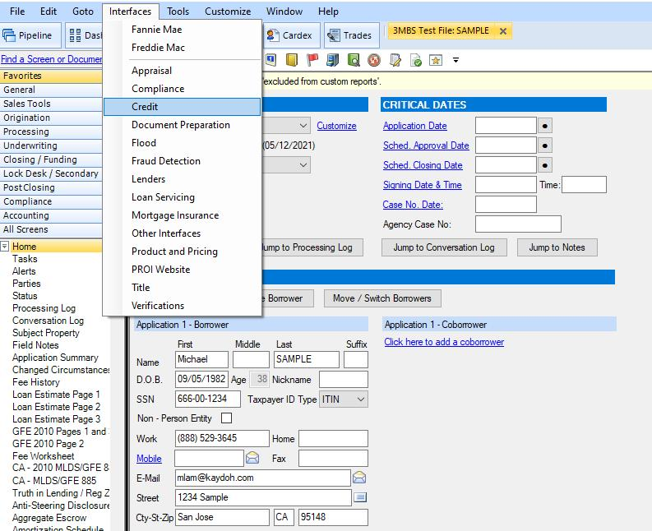

1. Select ‘Factual Data by CBC’

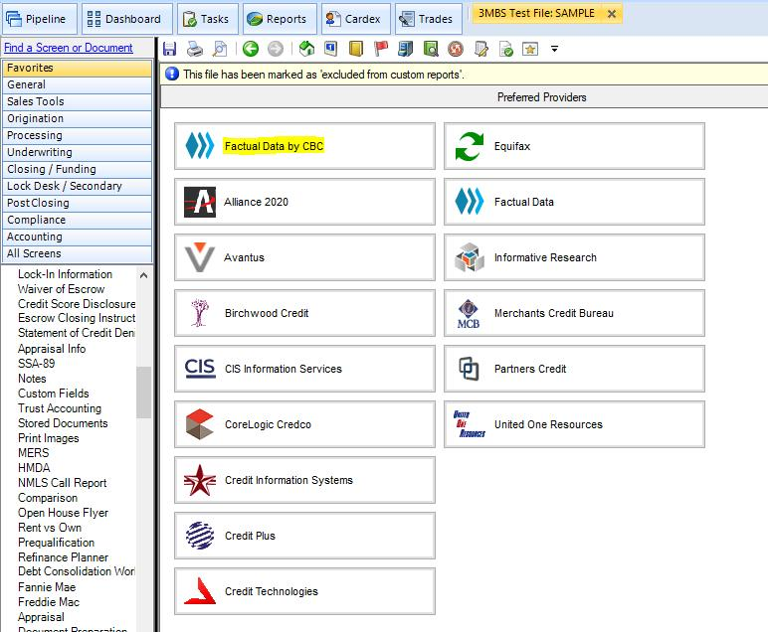

1. Verify Borrower information and click Submit

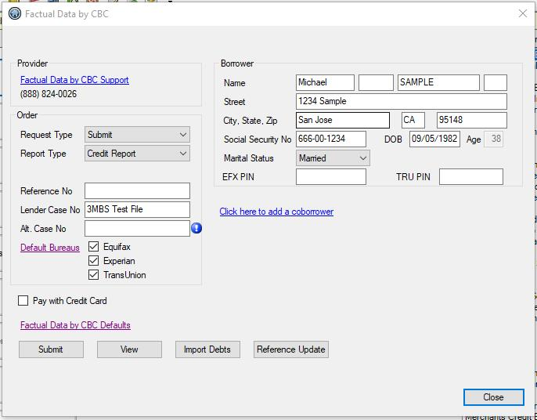

*You must be connected to the VPN or in the California offices to access this service.*

*If you have questions or issues reach out to your manager or the IT Department.*